REAL TIME COMMUNICATION SYSTEM POWERED BY AI

Submitted by

NALAYATHIRAN PROJECT BASED LEARNING

TEAM ID: PNT2022TNID30422

.P.ANUSIYA 611419106009

P.AARTHI 6114191001

S.PRABADEVI 611419106044

C.VENNILA 611419106075

In partial fulfillment for the award of the degree of

DEPARTMENT OF ELECTRONICS AND COMMUNICATION ENGINEERING

MAHENDRA ENGINEERING COLLEGE FOR WOMEN



KUMARAMANGALAM 205, NAMAKKAL MAIN ROAD, THIRUCHENGODE , TAMILNADU.

PROJECT REPORT

1. **INTRODUCTION**
   1. Project Overview
   2. Purpose
2. **LITERATURE SURVEY**
   1. Existing problem
   2. References
   3. Problem Statement Definition
3. **IDEATION & PROPOSED SOLUTION**
   1. Empathy Map Canvas
   2. Ideation & Brainstorming
   3. Proposed Solution
   4. Problem Solution fit
4. **REQUIREMENT ANALYSIS**
   1. Functional requirement
   2. Non-Functional requirements
5. **PROJECT DESIGN**
   1. Data Flow Diagrams
   2. Solution & Technical Architecture
   3. User Stories
6. **PROJECT PLANNING & SCHEDULING**
   1. Sprint Planning & Estimation
   2. Reports from JIRA
7. **CODING & SOLUTIONING (Explain the features added in the project along with code)**
   1. Feature 1
   2. Feature 2
   3. Database Schema (if Applicable)
8. **TESTING**
   1. Test Cases
   2. User Acceptance Testing
9. **RESULTS**
   1. Performance Metrics
10. **ADVANTAGES & DISADVANTAGES**
11. **CONCLUSION AND FUTURE SCOPE**

**13. APPENDIX**

Source Code

GitHub & Project Demo Link

# INTRODUCTION

## PROJECT OVERVIEW

* + 1. **ABSTRACT:**

Artificial Intelligence(AI) has proved its power and efficiency into different domains(industry, medicine, economic, etc), hoping for giving a chance for people with disabilities to change their life for the best. Basically, AI offers many advanced tools and machine learning algorithms that could support human capabilities, needs and preferences and improve User Experience (UX). In this paper, we focus on the impact of AI in Human Machine Interaction. Likewise, we aim to demonstrate what is the impact of AI on disability Human life. Finally, we proceed by introducing a revolutionary approach of adaptive user interfaces to users with special needs.

## PURPOSE

The recognition of sign language gestures from real time video and successfully classifying it into either one from a list of categories have been a popular and challenging field of research. Many researchers have been working on this field for a long time, so we have also thought of contributing to this field as by working on it in our final year major project.

Liang et al. [6] have also put their research on this concept which has guided us throughout the implementation. The process of recognizing a sign language gesture and classifying it is the one line definition of the task performed by this proposed system. Along with this, a text to ASL finger spelling feature is also available that makes the two-way communication from sign to text and text to sign possible. The following steps were taken while working on this project.Many vision-based and sensor-based techniques have been used for sign language recognition. Pavlovic et al. The paper published on 1997 emphasizes on the advantages and shortcomings and important differences in the gesture interpretation approaches depending on whether a 3D model of the human hand or an image appearance model of the human hand is used. As of the time, this survey was done 3D hand models offered a way of more elaborate modeling of hand gestures but lead to computational hurdles that had not been overcome given the real-time requirements of HCI.

# LITERATURE SURVEY

## INTRODUCTION:

Disability impacts negatively on human life. Each disability presents their specific barriers. These latter cause scarcity of people with disabilities from appropriate services that facilitate their specific tasks using interactive systems as they find difficulties in communicating with the user interfaces of digital applications (web, mobile, desktop, tv, etc).

Different solutions were proposed, but they still insufficient and not efficient considering the pervasive environment and the bunch of contextual information that contains. Otherwise, Artificial Intelligence (AI) is an emergent imitator technology to represent the human brain thinks by the integration of the machine’s from computing systems. computational power and speed with human perception and intelligence .

AI is in growing and possesses the necessary tools that could help users with disability experience in accessing information In fact, users with disability have to use interactive systems as well-bodied users. But, they are unable to do it, because user interfaces of interactive systems are not adapted to their capabilities. Therefore, we need to improve adaptive interactive systems in order to make them accessible to disabled users.

Accessibility of User Interfaces(UI)s is also an emergent and important domain that needs more and more investment . The solutions given are insufficient, superficial and limited to elementary disability. Therefore, to overcome all difficulties and challenges, we need to propose solutions that cover almost of users with disability from different cultural environments, considering almost of platforms used for the interaction. This paper consolidates research findings in collaboration between accessibility, user interfaces and artificial intelligence. In the end, we present a solution integrating accessibility, user interface and artificial intelligence.The transformative impact of artificial intelligence on our society will have far- reaching economic, legal, political and regulatory implications that we need to be discussing and preparing for. Determining who is at fault if an autonomous vehicle hurts a pedestrian or how to manage a global autonomous arms race are just a couple of examples of the challenges to be faced.

## ARTIFICIAL INTELLIGENCE IMPACT:

The traditional problems of AI research were how to provide tools for reasoning, knowledge representation, planning, learning, natural language processing, perception and the ability to move and manipulate objects. It had made success offering advanced functionalities in diverse modern domains such as speech recognition, images classifying, game playing, search engines and virtual assistants. It provided tools for organization, selection, filtration and searching for information. The rapid expansion of artificial intelligence is largely related to the popularization of Machine Learning. This scientific approach consists in letting the machines learn independently to perform tasks. Machine learning is a subset of AI that represents a mathematical model that learns how to recognise or to represent a concept through repeated exposure to samples of that concept . Machine Learning has made it possible to equal or even surpass human capacities. For instance, with ML algorithms we can transcript a speech, recognize an emotion, create video, etc.. Interactive Machine Learning (IML) is a set of learning algorithms which combine computational and human agents. IML has attracted interest among HumanComputer Interaction (HCI) researchers due to the unique aspects of establishing effective human interactions under this paradigm by integrating human experience and domain-knowledge. User with a disability could be the centre of the machine learning loop. IML paradigm is oriented in reinforcement learning, preference learning and active learning.

Natural Language Processing (NLP) is a powerful method to understand

human languages. It represents an algorithm to manage the interactions between human language and computers. NLP is a set of ML-based algorithms. With NLP, virtual assistants have to grow as Alexa or Siri .

As with most changes in life, there will be positive and negative impacts on society as artificial intelligence continues to transform the world we live in. How that will balance out is anyone’s guess and up for much debate and for many people to contemplate. As an optimist at heart, I believe the changes will mostly be good but could be challenging for some. Here are some of the challenges that might be faced (and we should be thinking about how to address them now) as well as several of the positive impacts artificial intelligence will have on society.

Therefore, several questions could be asked: how could AI between three essential parts: Human-Computer Interaction (HCI), Accessibility Context (AC change for better people with disabilities live? What challenges could the Artificial Intelligence attempt when applied to User Interface? How can a User Interface adaptation system give the way to improve its adapting behaviour for accuracy and efficiency? Hence, the challenge is to find an approximation) and Artificial Intelligence(AI) .

We have defined the accessibility context (AC) as any information describing the user disability, the information specifying the computing platform used and the information about the particular physical environment of the computing platform at a given user situation. In consequence, we consider the Accessibility Context as any information describing the Disability Profile, the User Identity, the User Situation, the Technical Context and the Environment Context.

## ADAPTIVE USER INTERFACES:

Artificial Intelligence has demonstrated its potential in advanced user interfaces by the growing of Adaptive User Interfaces(AUI) or Intelligent User Interfaces. These latter use Machine Learning based methods to personalize the UI behaviour according to the context of use. AUI has the potential to be adapted by itself automatically based on the context of use. It can benefit from Artificial Intelligence (AI) in general, and Machine Learning (ML) techniques . Therefore, we propose an Adaptive UI to Accessibility Context AUIAC, an intelligent generic model driven approach of adaptive user interfaces to a given accessibility context. AUIAC has several properties to provide usable and effective solution which are:

* Generic: AUIAC approach is considered generic since it has to be applied for a big range of disabilities and platforms. We need to make accessible a bunch of UI type which are the most used (web UI, mobile UI, desktop UI).
* Adaptive: The adapting system behaves accordingly to the accessibility context based on an adaptivity procedure. In fact, adaptivity automates a little bit the adaptation of the UI to users with special needs. Intelligent: When the context change, the UI has to change accordingly.

This procedure has to be automatic in order to match a large scale of accessibility context and all UIs aspects. Therefore, we are working on integrating Artificial Intelligence in all AUIAC modules based on algorithms of Machine Learning .

* Context-aware: AUIAC approach is an adaptation approach to the accessibility context. It has to take into account all context’s aspects. These latter are captured from different sensors connected to the device used. Hence, the approach must to provide a context manager to sense, collect, manage and send informations about context to the adaptation process to adapt the UI accordingly. Contextawareness leads to built pervasive computing interactive systems .

## REFERENCES:

1. J.J. Dudley, and P.O.Kristensson, A Review of User Interface Design for Interactive Machine Learning,ACM Trans. Interact. Intell. Syst. 1, 1, 2018.
2. Guangliang Li, Randy Gomez, Keisuke Nakamura, Bo He, HumanCentered Reinforcement Learning: A Survey, IEEE Transactions on Human -Machine Systems, Vol. 49, NO. 4, AUGUST 2019
3. Apple, https://[www.apple.com/siri/,](http://www.apple.com/siri/) 2019.
4. Amazon, https://[www.alexa.com/,](http://www.alexa.com/) 2019.
5. N. Mezhoudi, User interface adaptation based on user feedback and machine learning, pp 25-28, 2013.
6. T. Lavie and J. Meyer, Benefits and costs of adaptive user interfaces, International Journal of Human-Computer Studies vol 68,pp 508-524, 2010.
7. N. Indurkhya, F. J. Damerau, Handbook of Natural Language Processing, Chapman and Hall/CRC; 2 edition, 2010.
8. Y.Bendaly Hlaoui and L. Zouhaier and L.Jemni Ben Ayed, Model driven approach for adapting user interfaces to the context of accessibility: case of visually impaired users, Journal on Multimodal User Interfaces, 2018.

# IDEATION & PROPOSED SOLUTION

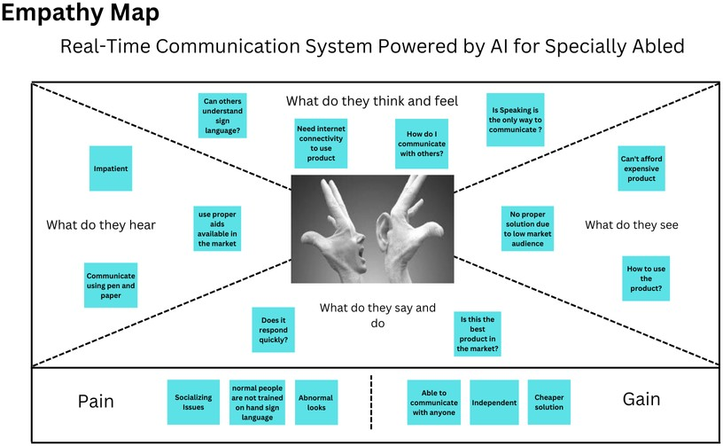

* 1. **Empathy Map Canvas**

# Ideation & Brainstorming

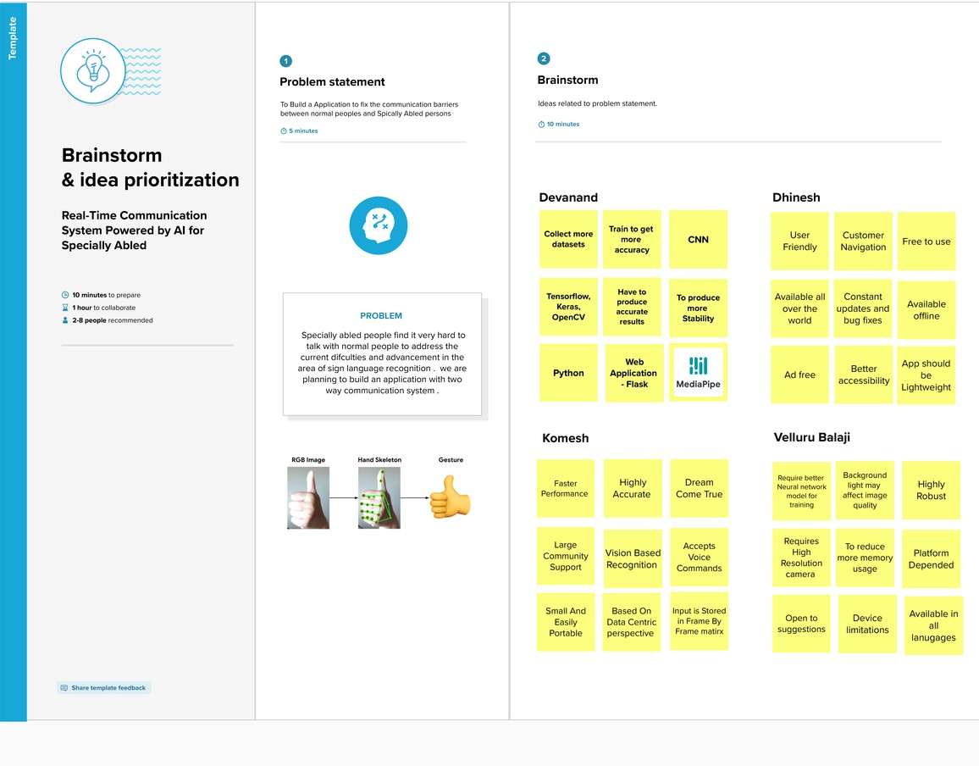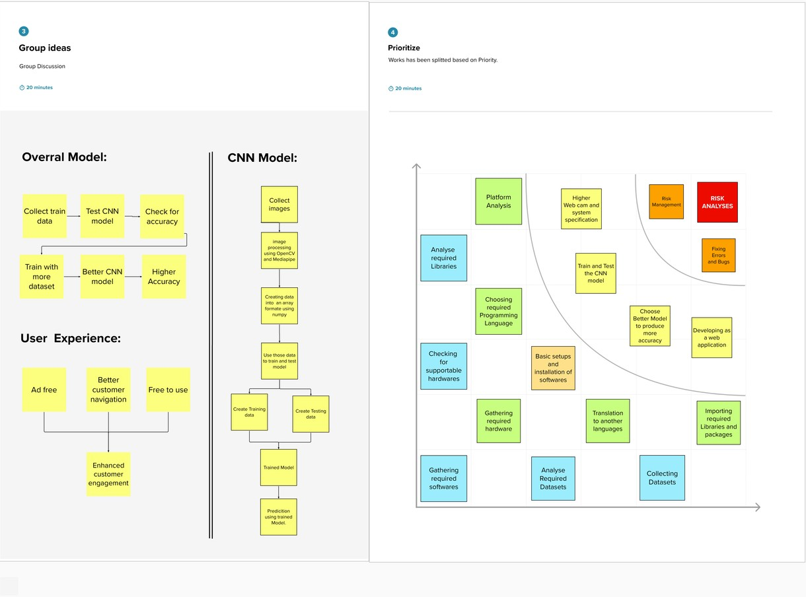

## Project Proposal

**S.NO**

**1**

**2**

**3**

**PARAMETER**

Problem Statement (Problem to be solved)

Idea / Solution description

Novelty / Uniqueness

**DESCRIPTION**

An application for deaf and dumb people to convey their information using signs which get converted to human-understandable language and speech in Artificial Intelligence.

• By using voice conversation system with hand gesture recognition and translation will be very useful to have a proper conversation.

• This makes two people to communicate in a easier and a efficient way

• We are using Convolution neural network to create a model that is trained on different hand gestures and an app is built for the use this mode.

• AI has been deployed/used in an efficient manner in the development of this idea.

Social Impact / Customer Satisfaction

**4**

* Communicating with others and being connected in the society and remove accessibility barriers.

• With clear results, two people can communicate with each other.

Business Model (Revenue Model)

**5**

* First, we offer free usage for everyone. Once our product is familiarized among people, we will turn the users to get the premium subscriptions by offering them with more premium features.
* As long as our product is beneficial to the users, subscriptions will increase which is a great business model, as this worked in case of many top MNC’s around the world.

Problem Statement (Problem to be solved)

**6**

* + Useful in organization where communication between co-workers is much important.
  + Can make collaborations with government.
  + Example: Tata Group made a collaboration with Indian government in educating people through Cutting- Edge, which is a great success.
  1. **Problem Solution Fit**

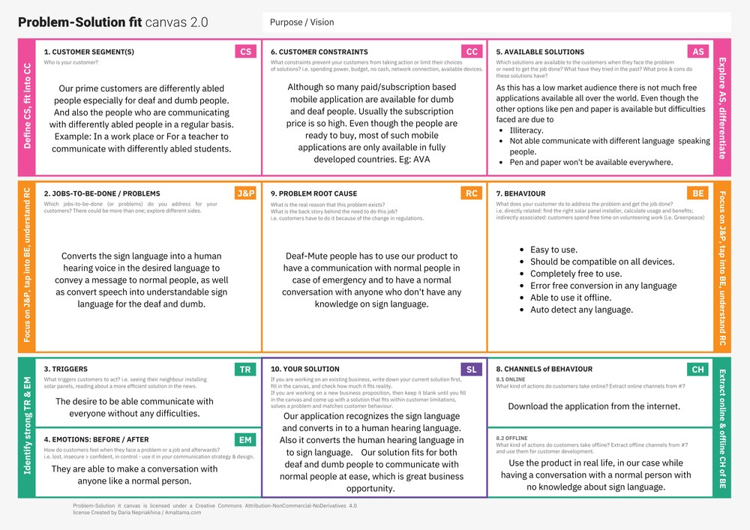

# REQUIREMENT ANALYSIS

## Functional & Non-functional

* + 1. **Functional Requirements:**

Following are the functional requirements of the proposed solution

**FR.NO**

**FR-1**

**FR-2**

**FR-3**

**FR-4**

**FR-5**

**FUNCTIONAL REQUIREMENTS**

User Registration

User Authentication

Reporting

Audio Tracking

Historical Data

**SUB REQUIREMENTS (STORY / SUB TASK)**

Registration through Form Registration through Gmail Registration through LinkedIn

Confirmation via Email Confirmation via OTP Confirmation via Voice Recognition

Any Problems faced by customer should be reported Automatically

StreamLine Through Audit processes and Comply with regulations or internal policy

Collected data form the past events must be used improve the further transaction

## Non-functional Requirements:

Following are the non-functional requirements of the proposed solution.

**NFR.NO**

NFR-1

NFR-2

NFR-3

NFR-4

NFR-5

NFR-6

**NON-FUNCTIONAL REQUIREMENT**

Usability

Security

Reliability

Performance

Availability

Scalability

**DESCRIPTION**

The User Interface should be contrast enough for the partially blind people and also should be colorblind friendly UI.

Should be resistive to cyberattacks as the information shared is very confidential.

Support should be provided for in-house or remote accessibility for external resources if required.

The site should load in 5 seconds when the number of simultaneous users are greater than 50000

Continuous availability of our service must be provided all the time

The application should run seamlessly with more than 50000 users at the same time

# PROJECT DESIGN

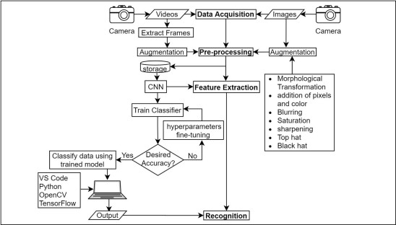

## DATAFLOW DIAGRAMS

**Data Flow Diagrams:**

A Data Flow Diagram (DFD) is a traditional visual representation of the information flows within a system. A neat and clear DFD can depict the right amount of the system requirement graphically. It shows how data enters and leaves the system, what changes the information, and where data is stored.

## SOLUTION & TECHNICAL ARCHITECTURE

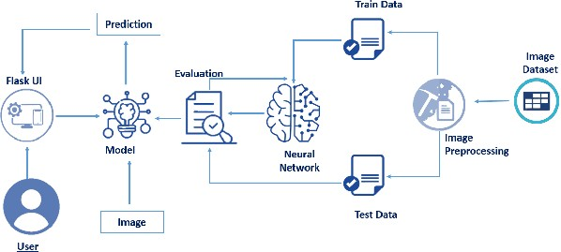

**TECHNICAL ARCHITECTURE**

The Deliverable shall include the architectural diagram as below and the information as per the table1 & table 2

## USER STORIES

**USER TYPE**

**Customer**

**Custmoer**

**Custmoer**

**Customer**

**FUNCTIONAL REQUIREMENT**

Registration

Login

.

Dashboard

Main Page

**USER STORY NUMBER**

USN-1

USN-2

USN-3

USN-4

**USER STORY / TASK**

Not Required

Not Required

Not Required

As a User, I can enter the web page once clicked, which provides be the Guidelines to use the app.

**Customer** Guidelines USN-5

As a User , I can give a read through the guidelines to understand the functioning of the app

**Customer** Convert Sign USN-6

As a User, I can click the button Convert sign , which directs me towards the Main screen

**Customer** Camera USN-7

As a User, I can show my hand sign towards the camera which converts them into text manner

**Customer** Voice Mode USN-8

Once the text is obtained, As a User I can click on the voice mode which provides the text in the form of speech.

# PROJECT PLANNING & SCHEDULING

## SPRINT PLANNING & ESTIMATION

* + 1. **SPRINT**-**1**

**Creating Sign up page :**

* + - 1. Creating Sign up page using HTML and CSS
      2. Using Bootsrap we styled the input fields and label tag.
      3. The Navigation is used for easier navigation for the user.
      4. We are planning to provide profile, about and home page button in the navigation bars with basic templates in sprint-1

## SPRINT-2

* + - 1. Collecting Datasets
      2. Creating CNN Model.
      3. Testing CNN Model.

## SPRINT-3

* + - 1. Creating the Main Flask App.
      2. Adding required functions to render the templates.

## SPRINT-4

* + - 1. Imported the prediction program to flask app
      2. Imported the trainlist to flask app
      3. Adding required functions to render the templates.
      4. Running the Flask App.(app.py)
      5. Testing the Flask App.
  1. **REPORTS FROM JIRA**

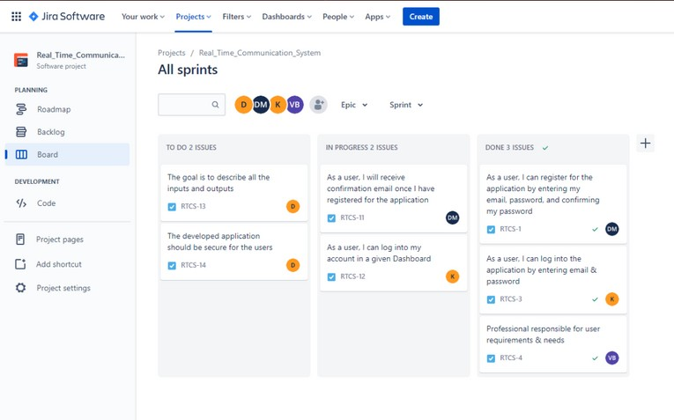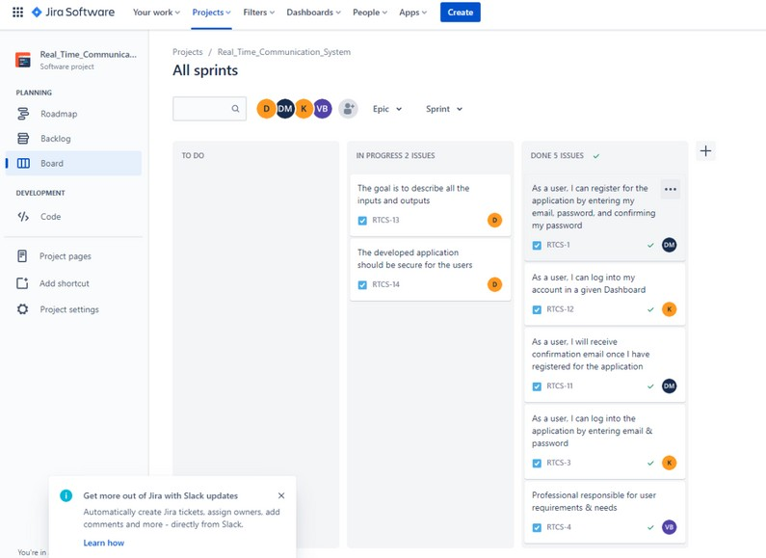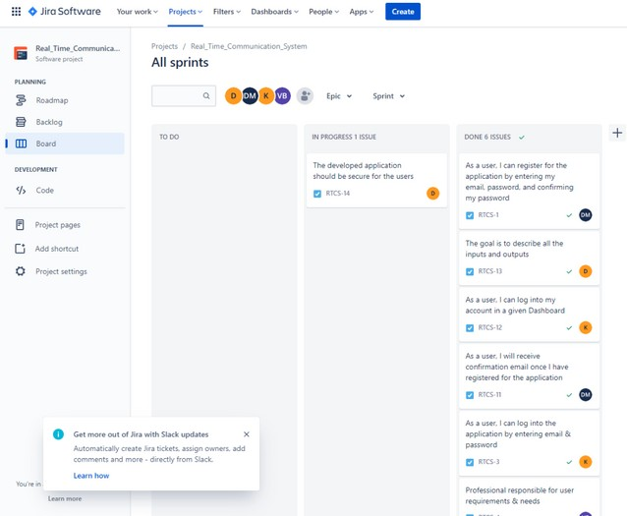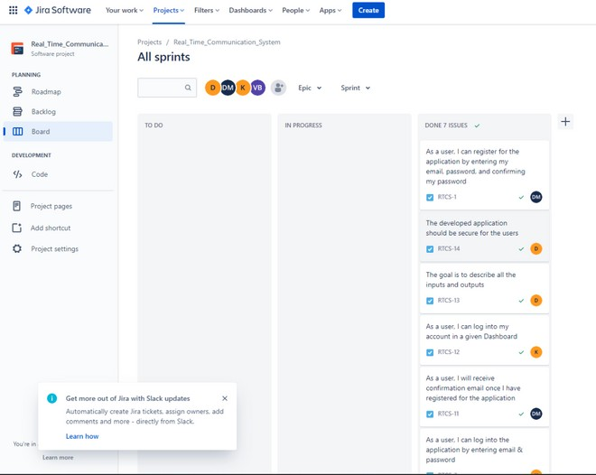

# CODING & SOLUTIONING

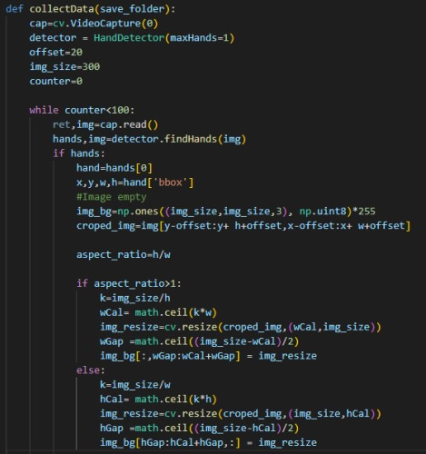

## FEATURE 1

* + 1. **CREATING CNN MODEL AND PREDICATION BASE PROGRAMS FOR DETECTING HAND SIGNS:**

### Collecting Datasets.

* + - * 1. Creating datacollection program to collect data from the user and detect the hands in the image frames add crop the detected hands and adding a background of size 300 x 300 px.
        2. Saving the collected image in a Data directory which contain Train and Test folder.

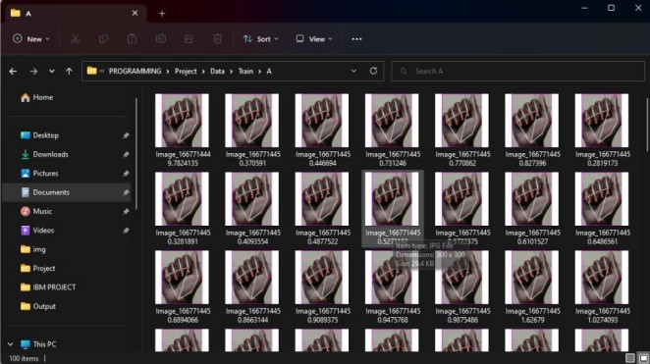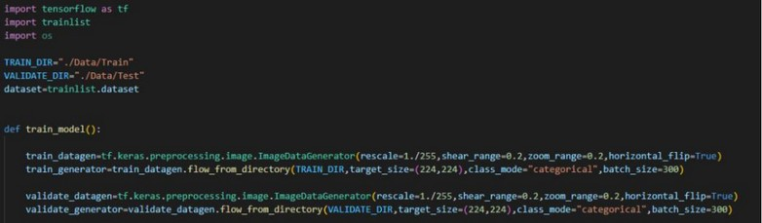

* + - * 1. Do this for all the dataset labels.
        2. With the help of mediapipe module all the dataset of hand contain tracking pipeline which helps to increase the detection accuracy.

### Creating CNN model

* + - * 1. Import the Tensorflow library to the python program for using the keras module to create CNN.
        2. Use Sequential module to build a CNN model and add the required layers such as Conv2D , Maxpool , Flatten , Dense layers.

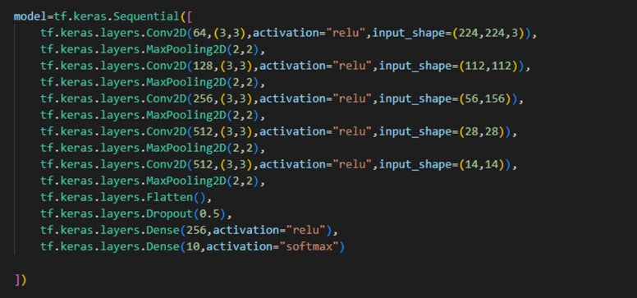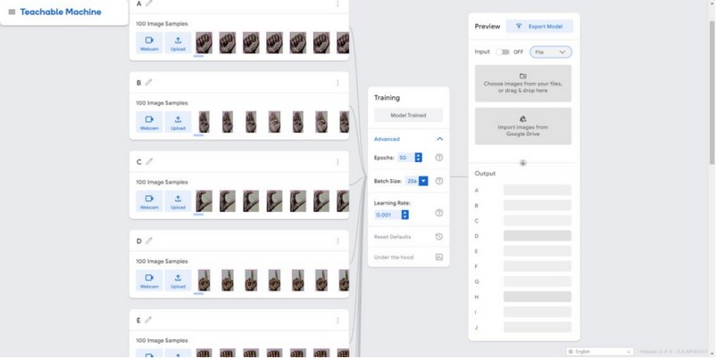

* + - * 1. To increase the accuracy and reduce the size of our model we use the TEACHABLE MACHINE tool of google to train our model.
        2. The Teachable machine produce high accuracy sequential model.

### Testing CNN model

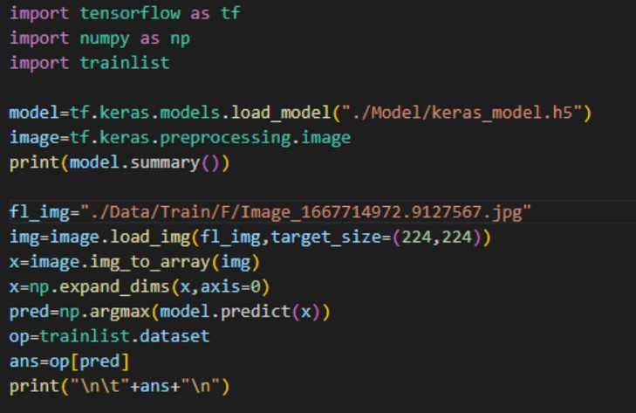

* + - * 1. By using the Tensorflow model we can predict the output of our

project.

* + - * 1. We use the cvzone library to predict the Hand Gestures and we also use this module to detect the hand in our image frame.

o

* + - * 1. Using this, our image predicting model can detect the intended output with higher accuracy.
        2. Our CNN Model is trained to localize the hand of the person who is trying to communicate, even in a messy background.
        3. It is trained to get the most desired aspect to detect the hand tracking with higher precision.

e. The '0' in the VideoCapture() method in the below program denotes the external camera connected to the device.

Ouotput

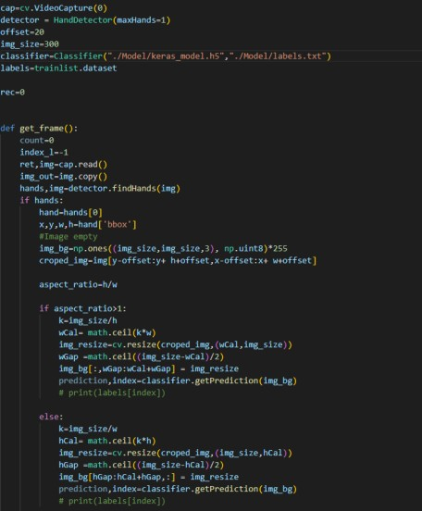

d. The maxHands=1 in the HandDetector() method in the above program denotes that we are detecting just the one hand of the person/user.

### Main Flask app:

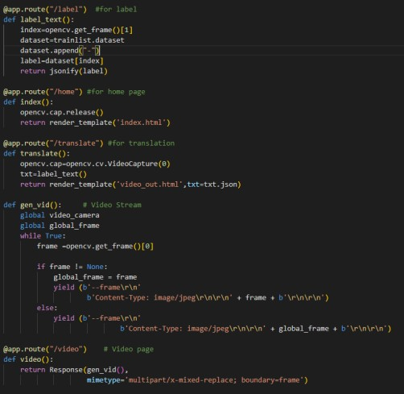

* 1. Create a flask app.

Command Line: from flask import Flask, ,render_template, Response, jsonify

* 1. Adding required functions to render the templates.

### Interfacing all the component to flask app :

1. Main Flask app:

1. Imported the prediction program to flask app import opencv
2. Imported train list to the flask app. import trainlist

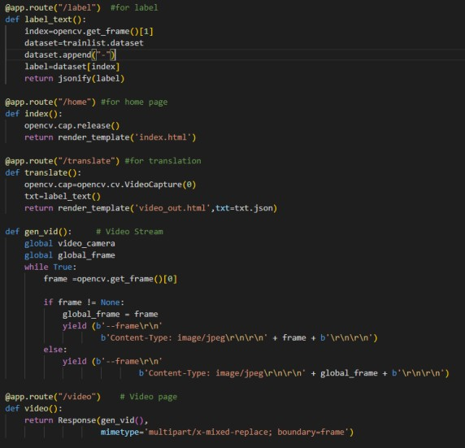

1. Adding required functions to render the templates.
2. Run the app.py (Flask App).

(Project) PS C:\Users\Deva\Documents\PROGRAMMING\Project> & c:/Users/Deva/Documents/PROGRAMMING/Project/Scripts/py thon.exe c:/Users/Deva/Documents/PROGRAMMING/Project/app.py

**MAIN PAGE:**

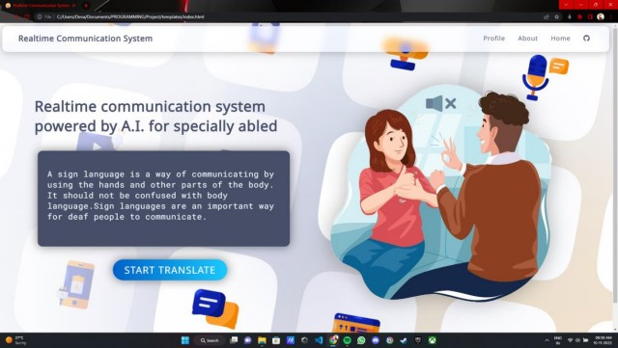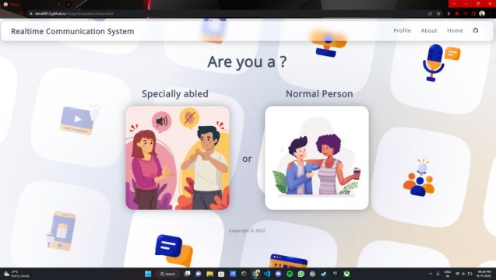

**CHOICE PAGE :**

**VIDEO TRANSLATE PAGE:**

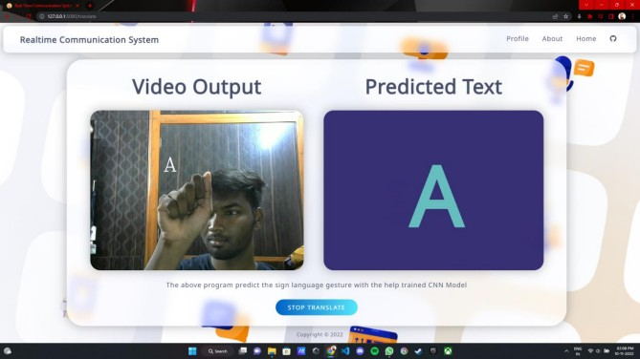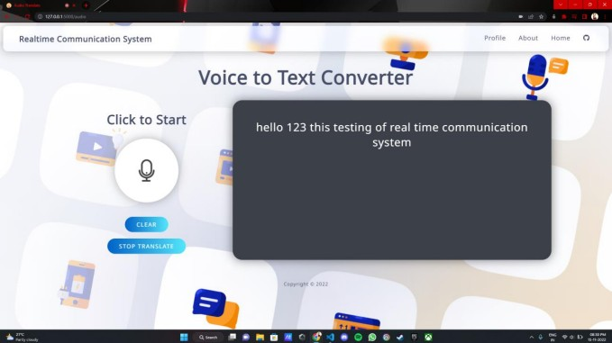

## AUDIO TRANSLATE PAGE:

**LOGIN PAGE :**

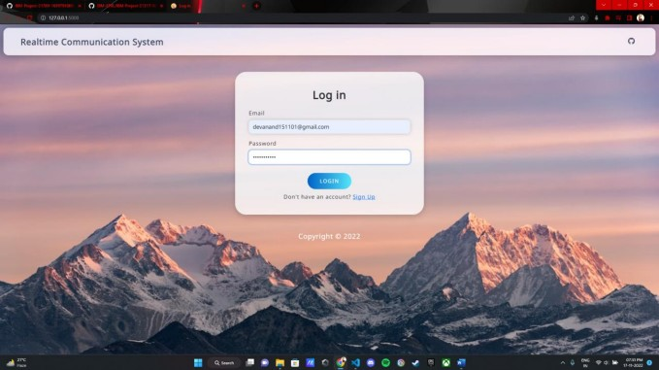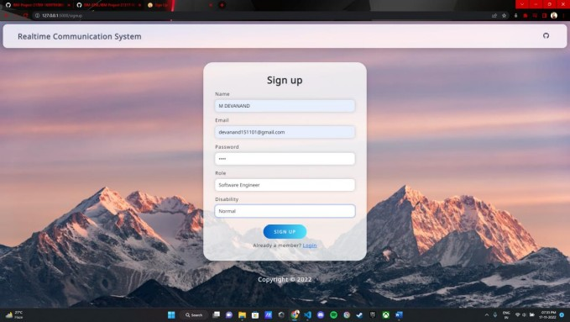

## SIGN UP PAGE :

**PROFILE PAGE :**

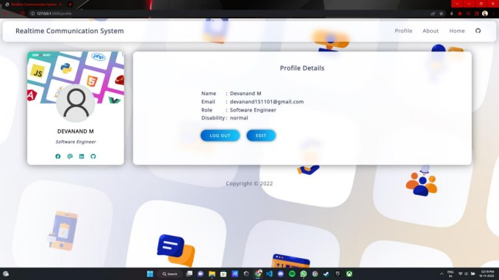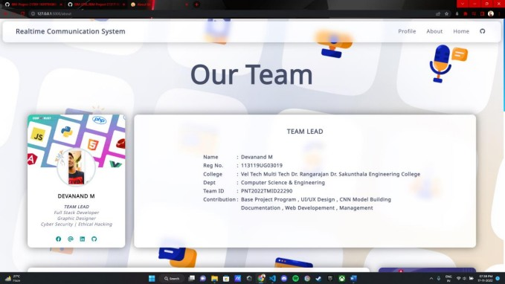

## ABOUT PAGE :

* 1. **FEATURE 2**

### Sending the data over HTTP Request

To serve the HTTP Request and Response over the internet, we have used the AJAX Library to build a rich internet appplication

### Storing the data over HTTP Request or Response

Since our application is much more dependent on the processing the input rather than storing, So we are using the Google Sheets API to store and fetch the data on the front end itself.

Which is also reducing the processing overload on the device that we are running our application.

### How we implemented

To call the Google Sheets API service, we have used the Google- provided [client libraries](https://cloud.google.com/apis/docs/client-libraries-explained).(App script)

### Discovery document

A [Discovery Document](https://developers.google.com/discovery/v1/reference/apis) is a machine-readable specification for describing and consuming REST APIs. It is used to build client libraries, IDE plugins, and other tools that interact with Google APIs. One service may provide multiple discovery documents. This service provides the following discovery document:

### Service endpoint

A [service endpoint](https://cloud.google.com/apis/design/glossary#api_service_endpoint) is a base URL that specifies the network address of an API service. One service might have multiple service endpoints. This service has the following service endpoint and all URIs below are relative to this service endpoint:

## DATABASE SCHEMA

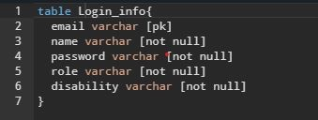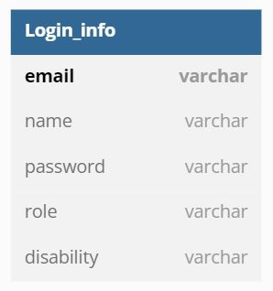

1. A database schema defines how data is organized within a relational database; this is inclusive of logical constraints such as, table names, fields, data types, and the relationships between these entities.
2. We have utilized a sql-based database structure(which is rows and column of data).
3. In our project we have used the Google Sheets as a database to store the user login info using App script.

# TESTING

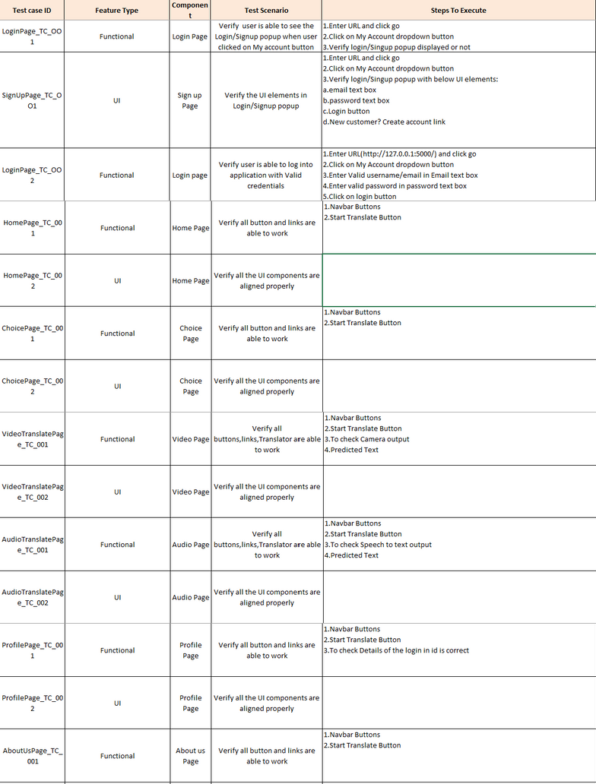

## TEST CASES

* 1. **USER ACCEPTANCE TESTING**

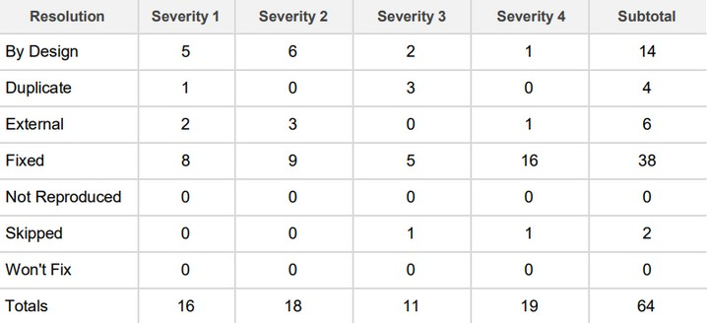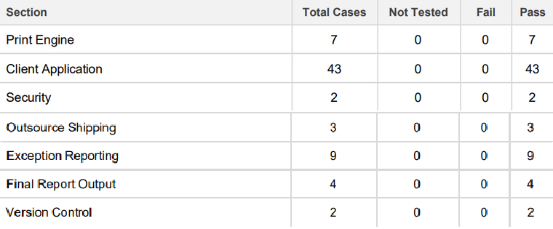

### Purpose of Document

The purpose of this document is to briefly explain the test coverage and open issues of the Real-Time Communication System Powered by AI for Specially Abled project at the time of the release to User Acceptance Testing (UAT).

### Defect Analysis

This report shows the number of resolved or closed bugs at each severity level, and how they were resolved.

### Test Case Analysis

This report shows the number of test cases that have passed, failed, and untested

# RESULTS

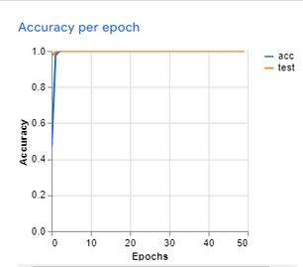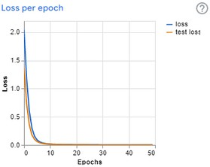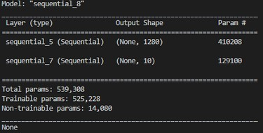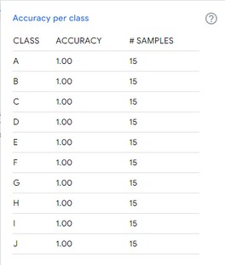

## PERFORMANCE METRICS

**RESULT – VARIATION OF ACCURACY**

**VARIATION OF LOSSES**

**CNN MODEL SUMMARY**

# ADVANTAGES & DISADVANTAGES

## ADVANTAGES

* + - Furthermore by seeing words in actions, it provides an additional way for people to recognise different words and phrases. Our application helps children and people with disabilityto see words in motion is a great way for them to retain information.
    - Being able to express their thoughts and feelings is key for any child’s well being. If they can’t get their message across, then they will never feel included in conversations or activities. This can be very problematic when children start nursery or school as they should be able to fully participate despite having a communication barrier.
    - Sign language increases a child’s vocabulary and helps them remember words as there is muscle memory involved. The more senses involved in their learning, the greater a child’s memory retention will be.

## DISADVANTAGES

* + - Environmental disturbance (e.g., lighting sensitivity, background, and camera position) decreases the accuracy.
    - Closure (e.g., some fingers, or an entire hand can be out of the field of view) may result in mistranslations.
    - Sign boundary detection (when a sign ends and the next begins).
    - Since, sign language requires the use of hands to make gestures. This can be a problem for people who do not have full use of their hands.
    - Even seemingly manageable disabilities such as Parkinson's or arthritis can be a major problem for people who must communicate using sign language. For such reasons the

# CONCLUSION AND FUTURE WORK

Adaptive User Interfaces are in growth due to the use of artificial intelligence which offers a big range of methods based on Machine Learning, Deep Learning and Reinforcement Learning Algorithms .

Therefore, Users with disabilities’ life has to change and evolve with the emergence of adaptive user interfaces. Additionally, encloses many challenges and opportunities in humanity future, it will empower Disabled user experience (DUX).

In this project, we proposed an idea for feasible communication between hearing impaired and normal person with the help of deep learning and machine learning approach.

This proposed work ensures the accuracy of 90.2 (under good lighting condition) using TensorFlow and Mediapipe.

There is ever the sounding challenge to develop a sign language system in data the collection remains invariant of the unconstraint environment. This project can be extended to the real time data.

# APPENDIX

## SOURCE CODE

**app.py**

from flask import Flask ,render_template,Response,jsonify import opencv

import trainlist

video_camera = None global_frame = None app=Flask( name )

@app.route("/label") #for label

def label_text(): index=opencv.get_frame()[1] dataset=trainlist.dataset dataset.append("-") label=dataset[index]

return jsonify(label)

@app.route("/home") #for home page def index():

opencv.cap.release()

return render_template('index.html')

@app.route("/translate") #for translation def translate(): opencv.cap=opencv.cv.VideoCapture(0) txt=label_text()

return render_template('video_out.html',txt=txt.json)

def gen_vid(): # Video Stream global video_camera

global global_frame while True:

frame =opencv.get_frame()[0]

if frame != None:

global_frame = frame yield (b'--frame\r\n'

b'Content-Type: image/jpeg\r\n\r\n' + frame + b'\r\n\r\n') else:

yield (b'--frame\r\n'

b'Content-Type: image/jpeg\r\n\r\n' + global_frame + b'\r\n\r\n')

@app.route("/video") # Video page def video():

return Response(gen_vid(),

mimetype='multipart/x-mixed-replace; boundary=frame')

@app.route("/about") # About page def about():

opencv.cap.release()

return render_template('about_us.html')

@app.route("/signup") # Sign up page def sign_up():

opencv.cap.release()

return render_template('sign_up.html')

@app.route("/") #for login page def login():

opencv.cap.release()

return render_template('login.html')

@app.route("/profile") # Profile page def profile():

opencv.cap.release()

return render_template('profile.html')

@app.route("/choice") # Choice page def choice():

opencv.cap.release()

return render_template('choice.html')

@app.route("/audio") # Audio page def audio():

opencv.cap.release()

return render_template('audio_out.html') # Copyrigths:

# Devanand # Dhinesh

# opencv.cap.release()

if name ==" main ":

app.run(host='0.0.0.0', threaded=True , debug=True)

**opencv.py:**

import cv2 as cv

from cvzone.HandTrackingModule import HandDetector import numpy as np

import math

from cvzone.ClassificationModule import Classifier import trainlist

cap=cv.VideoCapture(0)

detector = HandDetector(maxHands=1) offset=20

img_size=300 classifier=Classifier("./Model/keras_model.h5","./Model/labels.txt") labels=trainlist.dataset

rec=0

def get_frame(): count=0 index_l=-1

ret,img=cap.read() img_out=img.copy() hands,img=detector.findHands(img) if hands:

hand=hands[0] x,y,w,h=hand['bbox'] #Image empty

img_bg=np.ones((img_size,img_size,3), np.uint8)*255 croped_img=img[y-offset:y+ h+offset,x-offset:x+ w+offset]

aspect_ratio=h/w

if aspect_ratio>1: k=img_size/h

wCal= math.ceil(k*w) img_resize=cv.resize(croped_img,(wCal,img_size))

wGap =math.ceil((img_size-wCal)/2) img_bg[:,wGap:wCal+wGap] = img_resize prediction,index=classifier.getPrediction(img_bg) # print(labels[index])

else:

k=img_size/w

hCal= math.ceil(k*h) img_resize=cv.resize(croped_img,(img_size,hCal)) hGap =math.ceil((img_size-hCal)/2) img_bg[hGap:hCal+hGap,:] = img_resize prediction,index=classifier.getPrediction(img_bg) # print(labels[index])

cv.putText(img_out,labels[index],(x,y-20),cv.FONT_HERSHEY_COMPLEX,2, (255,255,255),2)

# cv.imshow("Image_croped",croped_img) # cv.imshow("Image_bg",img_bg) index_l=index

if ret: ret,jpeg=cv.imencode('.jpg',img_out) return jpeg.tobytes(),index_l

else:

return None

## [requirements.txt](https://github.com/IBM-EPBL/IBM-Project-21317-1659777635/blob/main/Project Development Phase/Sprint 4/Project/requirements.txt)

absl-py==1.3.0 asttokens==2.1.0 astunparse==1.6.3 attrs==22.1.0 backcall==0.2.0 boar==0.0.1 boto3==1.26.3 botocore==1.29.3 cachetools==5.2.0 certifi==2022.9.24

charset-normalizer==2.1.1 click==8.1.3 colorama==0.4.6 contourpy==1.0.6 cvzone==1.5.6 cycler==0.11.0 debugpy==1.6.3 decorator==5.1.1 distlib==0.3.6 docopt==0.6.2 entrypoints==0.4 executing==1.2.0 filelock==3.8.0 Flask==2.2.2 flatbuffers==22.10.26 fonttools==4.38.0 gast==0.4.0

google-auth==2.14.0

google-auth-oauthlib==0.4.6 google-pasta==0.2.0 grpcio==1.50.0 h5py==3.7.0

Hand-Tracking-Module==0.1 ibm-cos-sdk==2.12.0

ibm-cos-sdk-core==2.12.0

ibm-cos-sdk-s3transfer==2.12.0

ibm-watson-machine-learning==1.0.257 idna==3.4

imageio==2.22.4 importlib-metadata==5.0.0 imutil==0.3.3 imutils==0.5.4 ipykernel==6.17.0 ipython==8.6.0 itsdangerous==2.1.2 jedi==0.18.1 Jinja2==3.1.2 jmespath==0.10.0 joblib==1.2.0 jupyter_client==7.4.4 jupyter_core==4.11.2 jyserver==0.0.5 keras==2.10.0

Keras-Preprocessing==1.1.2 kiwisolver==1.4.4 labelImg==1.8.6 libclang==14.0.6 lomond==0.3.3

lxml==4.9.1 Markdown==3.4.1 MarkupSafe==2.1.1 matplotlib==3.6.2 matplotlib-inline==0.1.6 mediapipe==0.8.11

nest-asyncio==1.5.6 networkx==2.8.8 numpy==1.23.4 oauthlib==3.2.2

opencv-contrib-python==4.6.0.66 opencv-python==4.6.0.66

opt-einsum==3.3.0 packaging==21.3 pandas==1.4.4

parso==0.8.3 pickleshare==0.7.5 Pillow==9.3.0 pipreqs==0.4.11 platformdirs==2.5.3 prompt-toolkit==3.0.32 protobuf==3.19.6 psutil==5.9.3

pure-eval==0.2.2 pyasn1==0.4.8

pyasn1-modules==0.2.8 Pygments==2.13.0 pyparsing==3.0.9 PyQt5==5.15.7

PyQt5-Qt5==5.15.2 PyQt5-sip==12.11.0

python-dateutil==2.8.2 pytz==2022.6 PyWavelets==1.4.1 pywin32==304 pyzmq==24.0.1 requests==2.28.1 requests-oauthlib==1.3.1 rsa==4.9 s3transfer==0.6.0

scikit-image==0.19.3 scikit-learn==1.1.3 scipy==1.9.3 six==1.16.0

sklearn==0.0 stack-data==0.6.0 tabulate==0.9.0

tensorboard==2.10.1 tensorboard-data-server==0.6.1 tensorboard-plugin-wit==1.8.1 tensorflow==2.10.0

tensorflow-estimator==2.10.0

tensorflow-io-gcs-filesystem==0.27.0 termcolor==2.1.0 threadpoolctl==3.1.0 tifffile==2022.10.10

tornado==6.2 tqdm==4.64.1 traitlets==5.5.0 typing_extensions==4.4.0 urllib3==1.26.12 virtualenv==20.16.6

watson-machine-learning-client==1.0.391 wcwidth==0.2.5

Werkzeug==2.2.2 wrapt==1.14.1 yarg==0.1.9 zipp==3.10.0

**Labels.txt 0 A**

1. **B**
2. **C**
3. **D**
4. **E**
5. **F**
6. **G**
7. **H**
8. **I**
9. **J**

**runtime.txt**

python-3.10.5

**GitHub & Project Demo Link**

https://github.com/IBM-EPBL/IBM-Project-21317-1659777635 https://youtu.be/D1CLFeL1HVk